Model.java

package com.example.demo.model;

import org.springframework.data.annotation.Id;

import org.springframework.data.mongodb.core.mapping.Document;

@Document(collection = "student")

public class Student {

@Id

public int age;

public String name;

public long salary;

public Student(int age, String name, long salary) {

super();

this.age = age;

this.name = name;

this.salary = salary;

}

public long getSalary() {

return salary;

}

public void setSalary(long salary) {

this.salary = salary;

}

public int getAge() {

return age;

}

public void setAge(int age) {

this.age = age;

}

public String getName() {

return name;

}

public void setName(String name) {

this.name = name;

}

}

Controller.java

package com.example.demo.controller;

import java.util.List;

import org.springframework.beans.factory.annotation.Autowired;

import org.springframework.web.bind.annotation.DeleteMapping;

import org.springframework.web.bind.annotation.GetMapping;

import org.springframework.web.bind.annotation.PathVariable;

import org.springframework.web.bind.annotation.PostMapping;

import org.springframework.web.bind.annotation.PutMapping;

import org.springframework.web.bind.annotation.RequestBody;

import org.springframework.web.bind.annotation.RequestMapping;

import org.springframework.web.bind.annotation.RestController;

import com.example.demo.model.Student;

import com.example.demo.service.StudentService;

@RestController

@RequestMapping("/student")

public class StudentController {

@Autowired

StudentService studentService;

@GetMapping("/getByName/{name}")

public List<Student> getBySytudent(@PathVariable("name") String name) {

return studentService.findByName(name);

}

@PostMapping("/post")

public Student post(@RequestBody Student student) {

return studentService.post(student);

}

@PutMapping("/put")

public Student put(@RequestBody Student student) {

return studentService.put(student);

}

@DeleteMapping("/delete")

public String removeStudent(String name)

{

return studentService.deleteStudent(name);

}

}

Repository.java

package com.example.demo.repo;

import java.util.List;

import org.springframework.data.mongodb.repository.MongoRepository;

import com.example.demo.model.Student;

public interface StudentRepository extends MongoRepository<Student, Integer> {

List<Student> findByName(String name);

}

Service.java

package com.example.demo.service;

import java.util.List;

import org.springframework.beans.factory.annotation.Autowired;

import org.springframework.stereotype.Service;

import com.example.demo.model.Student;

import com.example.demo.repo.StudentRepository;

@Service

public class StudentService {

@Autowired

StudentRepository studentrepository;

public List<Student> findByName(String name) {

return studentrepository.findByName(name);

}

public Student post(Student student) {

return studentrepository.save(student);

}

public Student put(Student student) {

return studentrepository.save(student);

}

public String deleteStudent(String name) {

List<Student> list = studentrepository.findByName(name);

studentrepository.deleteAll(list);

return "deleted";

}

}

Junit test cases

package com.example.demo;

import static org.mockito.Mockito.when;

import java.util.ArrayList;

import java.util.List;

import org.junit.jupiter.api.Test;

import org.springframework.beans.factory.annotation.Autowired;

import org.springframework.boot.test.autoconfigure.web.servlet.WebMvcTest;

import org.springframework.boot.test.mock.mockito.MockBean;

import org.springframework.test.web.servlet.MockMvc;

import com.example.demo.model.Student;

import com.example.demo.service.StudentService;

@WebMvcTest(value = StudentService.class)

public class StudentTest {

@Autowired

MockMvc mockMvc;

@MockBean

StudentService studentService;

@Test

void testGetByName() {

List<Student> list = new ArrayList<>();

Student student = new Student(25,"chandu",34333);

list.add(student);

when(studentService.findByName("chandu")).thenReturn(list);

}

}

Post crud operations

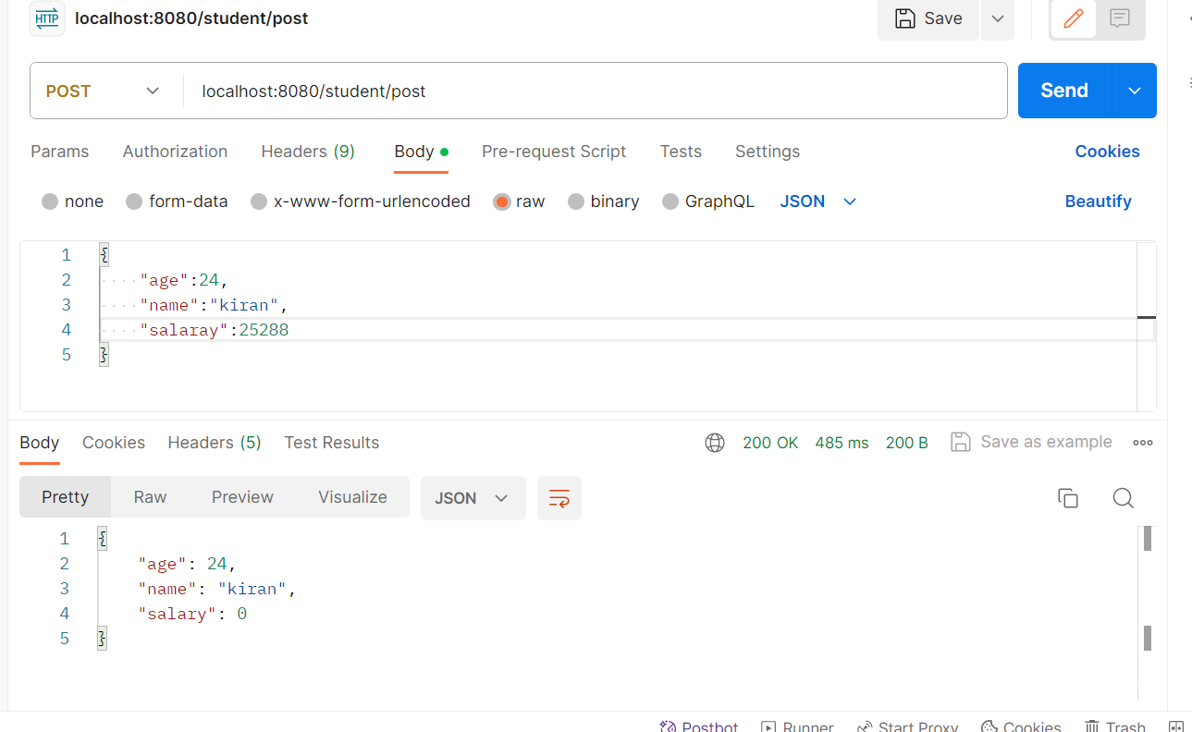

Put crud operator

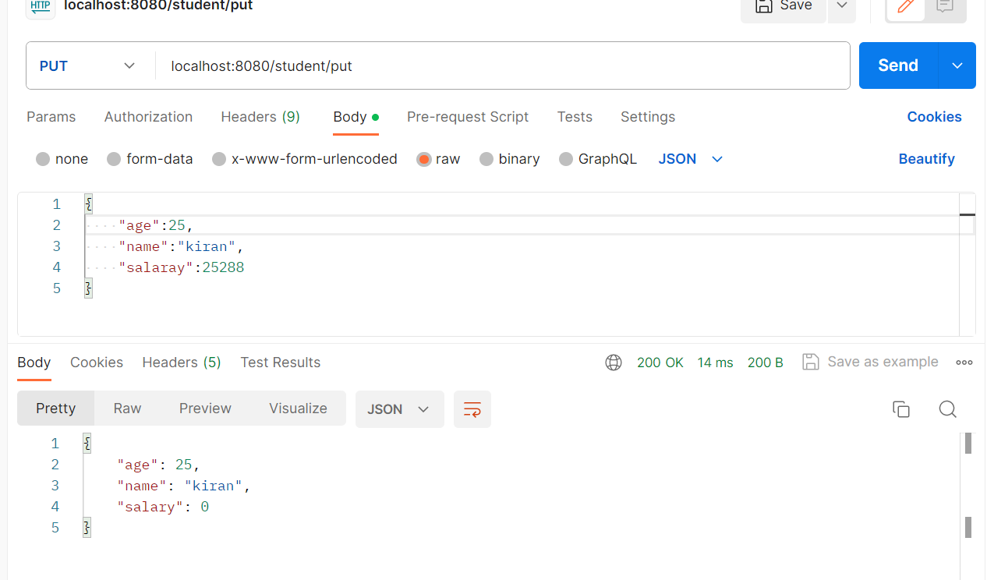

Delete crud operator

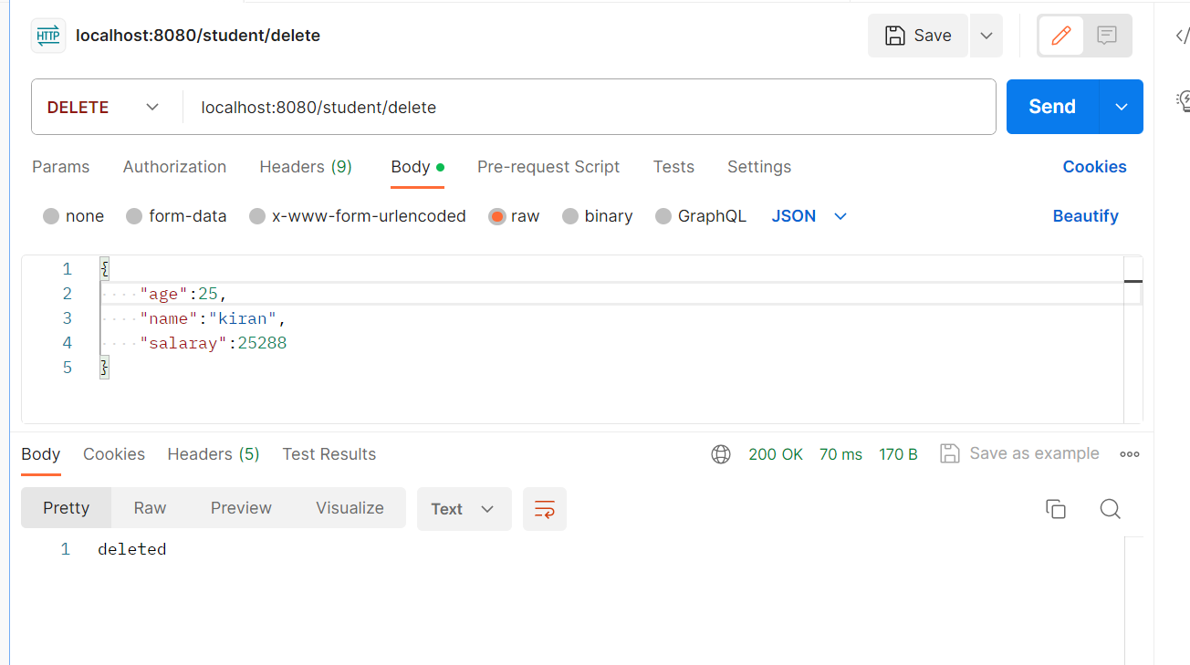

Junit test case

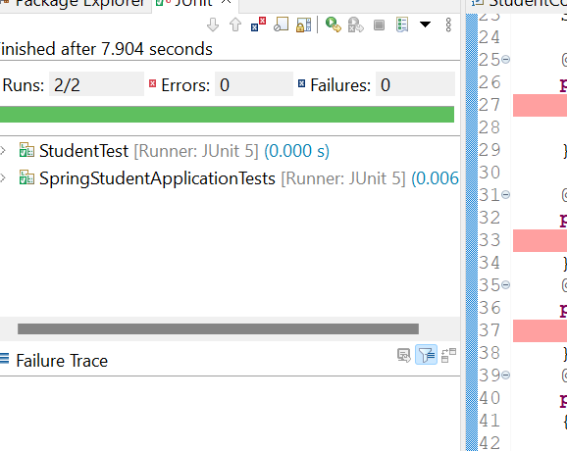

Code coverage

